
POE PART 1
PROGRAMMING

September 4, 2026
SILINDOKUHLE MAKUNGA
ROSEBANK COLLEGE, CAPE TOWN

SECTION A

RaceDay ERD
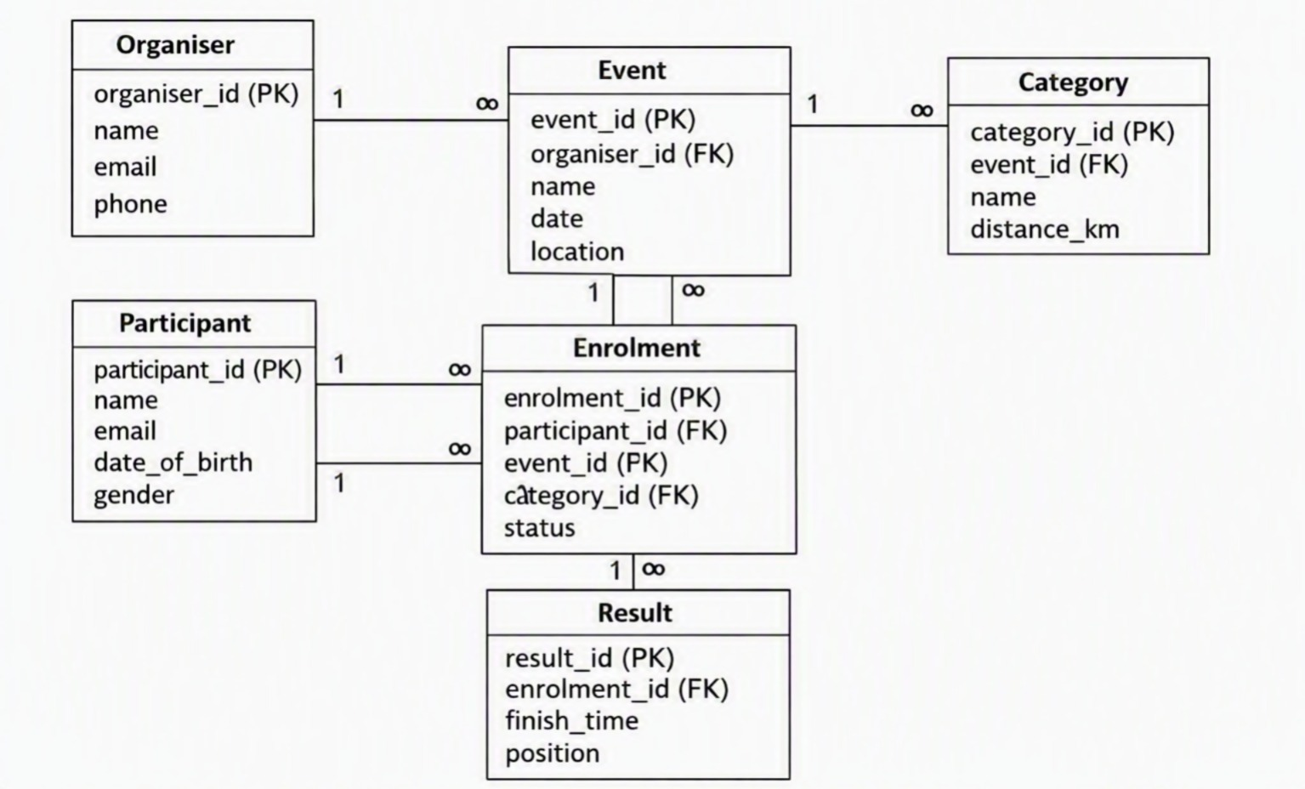

SECTION B
HTTP Method | Route | Description | Role Required | Request Body | Expected Response
POST | /api/auth/register | Register a new participant | None | { name, email, password } | 201 Created – user profile
POST | /api/auth/login | Authenticate user | None | { email, password } | 200 OK – JWT token
GET | /api/profile | Get logged-in user profile | Any | None | 200 OK – profile JSON
POST | /api/events | Create a new event | Organiser | { name, date, location } | 201 Created – event record
GET | /api/events | List all events | Any | None | 200 OK – events array
POST | /api/events/{id}/categories | Add category to event | Organiser | { name, distance_km } | 201 Created – category record
POST | /api/events/{id}/enrol | Enrol participant | Participant | { category_id } | 201 Created – enrolment record
POST | /api/results | Record race result | Organiser | { enrolment_id, finish_time, position } | 201 Created – result record

